OUTPUT FOR TASK-3
Prediction curve :
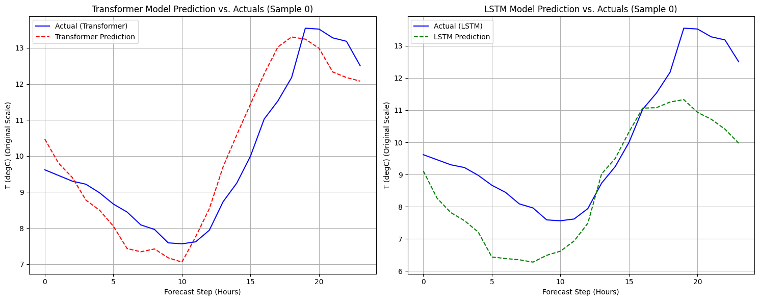
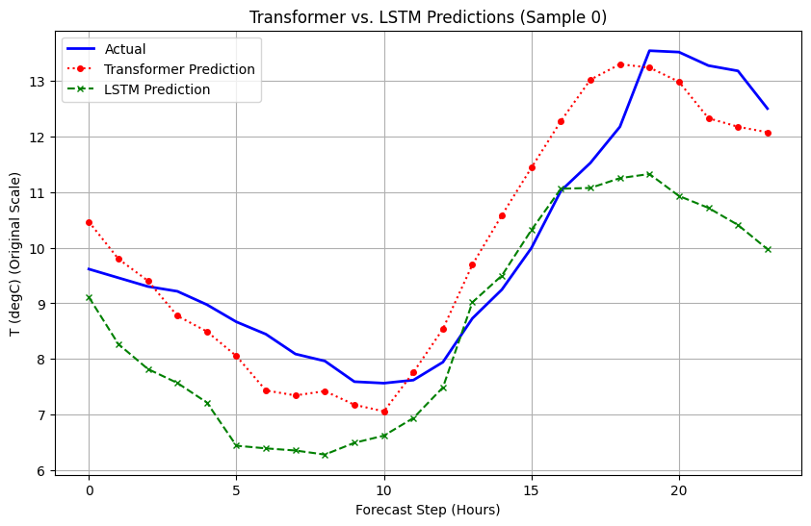
FOR TRANSFORMER MODEL:
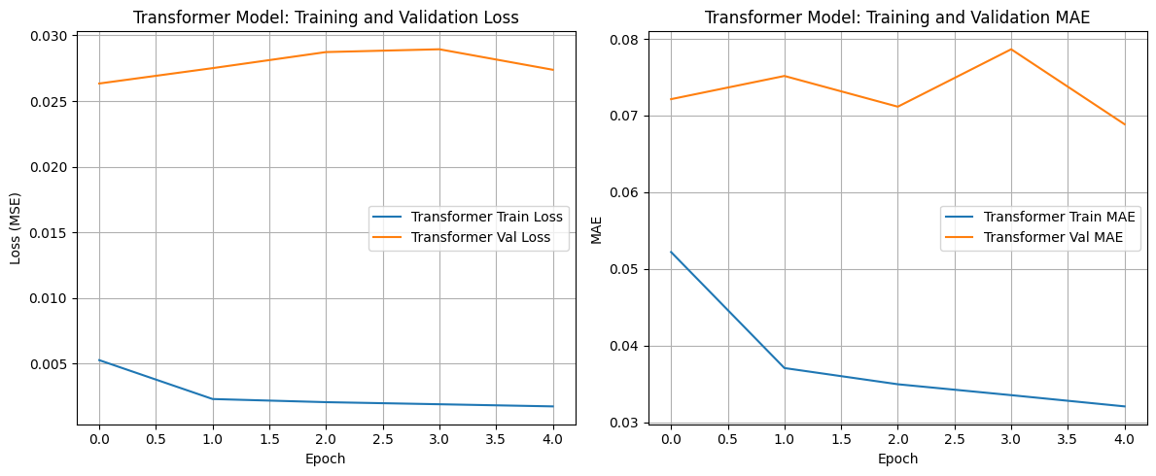
FOR LSTM MODEL:
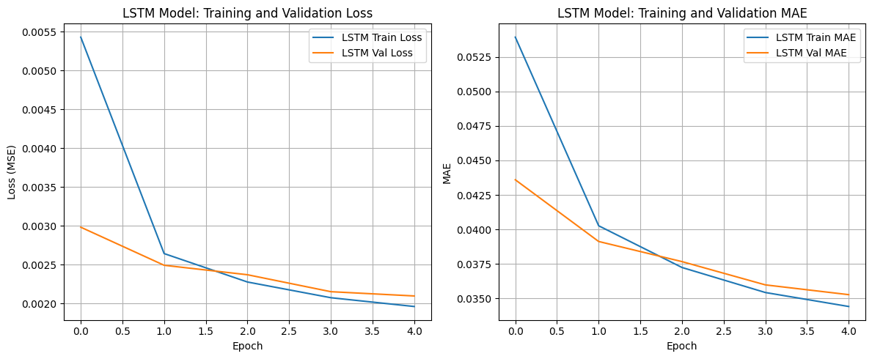
ACTUAL VS PREDICTED TEMPERATURE USING TESTING SET :
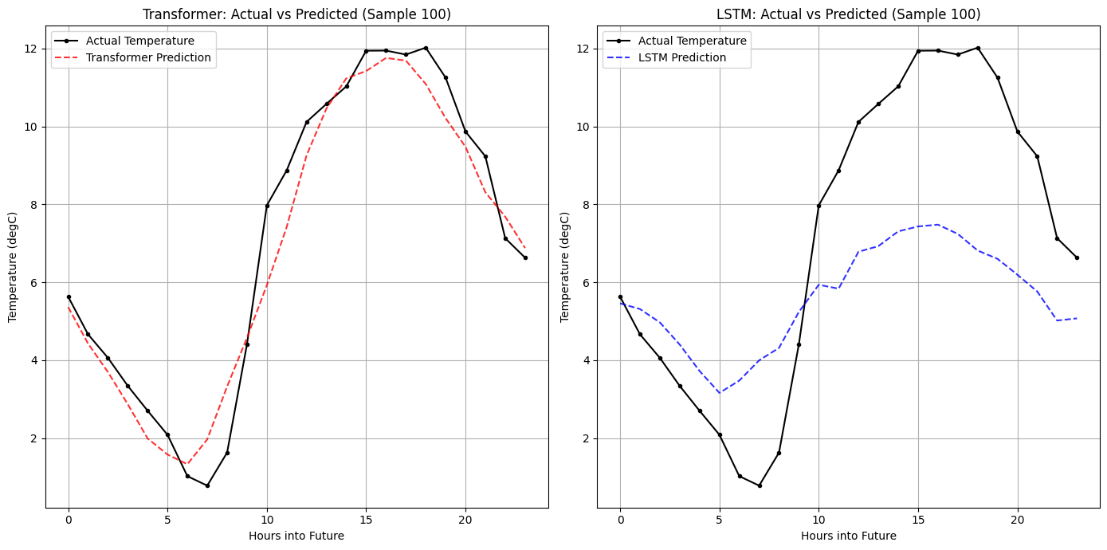
ACTUAL VS PREDICTED TEMPERATURE USING TRAINING SET :
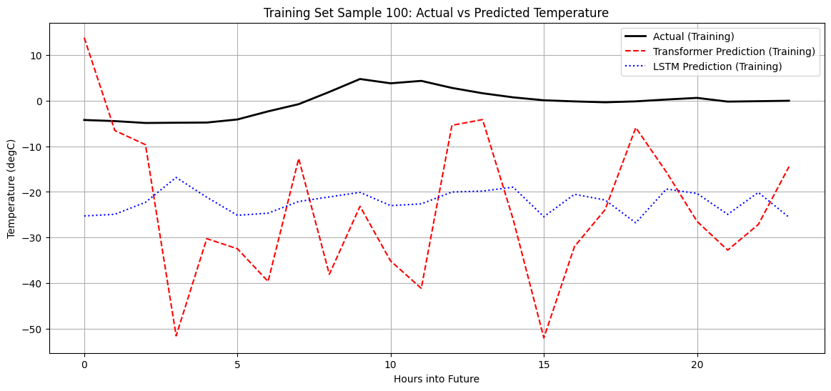

1. Quantitative Metrics
Model | Test MSE | Test MAE
Transformer | 0.0016 | 0.0689
LSTM | 0.0017 | 0.0353

Transformer is best compare to LSTM

Training Stability and Overfitting
- LSTM: The LSTM model showed more consistent training and validation loss/MAE curves. Its validation metrics tended to decrease steadily, suggesting a stable learning process and less immediate signs of overfitting during the observed epochs.
- Transformer: While the Transformer achieved a lower test error, its validation loss and MAE sometimes showed slight increases or more fluctuations in later epochs (as seen in the transformer_history plots), indicating that early stopping was beneficial in preventing potential overfitting. The Transformer's ability to capture complex dependencies can sometimes lead to memorization if not regularized properly.
Architectural Strengths
- Transformer: Excels at capturing long-range dependencies due to its self-attention mechanism, which can weigh the importance of all input elements regardless of their position. This is particularly advantageous for very long input sequences (SEQ_LEN = 720 hours).
- LSTM: While LSTMs are designed to handle sequences and mitigate the vanishing gradient problem, their ability to process extremely long sequences can still be limited by the sequential nature of their recurrence. They might struggle more than Transformers with very distant dependencies without sufficient depth or sophisticated gating.
Computational Considerations
- Transformer: Generally more computationally intensive, especially during training, due to the quadratic complexity of self-attention with respect to sequence length (though optimizations like sparse attention exist). This can lead to slower training times per epoch compared to LSTMs.
- LSTM: Typically has a more linear computational complexity with respect to sequence length, making it potentially faster for training on very long sequences if the number of layers is kept reasonable.
Prediction Quality (Visual Inspection)
- Observation: From the prediction plots generated previously, both models generally followed the actual temperature trends reasonably well. The Transformer often showed a slightly smoother and more accurate curve, especially at capturing peaks and troughs, though both exhibited some deviations.

Conclusion
Both models demonstrated strong capabilities in time series forecasting for the Jena climate dataset. The Transformer model slightly outperformed the LSTM in terms of raw MSE and MAE on the test set, suggesting a marginal advantage in predictive accuracy. However, the LSTM exhibited slightly more stable training behavior. The choice between them often depends on specific requirements, including the importance of capturing very long-range dependencies, available computational resources, and tolerance for potential training instabilities

